**Practical 3a: Registration**

import java.sql.Connection;

import java.sql.DriverManager;

import java.sql.ResultSet;

import java.sql.SQLException;

import java.sql.Statement;

import java.util.logging.Level;

import java.util.logging.Logger;

import javax.swing.JOptionPane;

/*

* To change this license header, choose License Headers in Project Properties.

* To change this template file, choose Tools | Templates

* and open the template in the editor.

*/

/**

*

* @author bot

*/

public class pract2A extends javax.swing.JFrame {

/**

* Creates new form pract2A

*/

public pract2A() {

initComponents();

}

/**

* This method is called from within the constructor to initialize the form.

* WARNING: Do NOT modify this code. The content of this method is always

* regenerated by the Form Editor.

*/

@SuppressWarnings("unchecked")

// <editor-fold defaultstate="collapsed" desc="Generated Code">

private void initComponents() {

jLabel1 = new javax.swing.JLabel();

jLabel2 = new javax.swing.JLabel();

jLabel3 = new javax.swing.JLabel();

jTextField1 = new javax.swing.JTextField();

jTextField2 = new javax.swing.JTextField();

jTextField3 = new javax.swing.JTextField();

jButton1 = new javax.swing.JButton();

setDefaultCloseOperation(javax.swing.WindowConstants.EXIT_ON_CLOSE);

jLabel1.setText("Username");

jLabel2.setText("Password");

jLabel3.setText("Mobile no");

jButton1.setText("Register");

jButton1.addActionListener(new java.awt.event.ActionListener() {

public void actionPerformed(java.awt.event.ActionEvent evt) {

jButton1ActionPerformed(evt);

}

});

javax.swing.GroupLayout layout = new javax.swing.GroupLayout(getContentPane());

getContentPane().setLayout(layout);

layout.setHorizontalGroup(

layout.createParallelGroup(javax.swing.GroupLayout.Alignment.LEADING)

.addGroup(javax.swing.GroupLayout.Alignment.TRAILING, layout.createSequentialGroup()

.addContainerGap(104, Short.MAX_VALUE)

.addGroup(layout.createParallelGroup(javax.swing.GroupLayout.Alignment.LEADING)

.addGroup(layout.createSequentialGroup()

.addGroup(layout.createParallelGroup(javax.swing.GroupLayout.Alignment.LEADING)

.addComponent(jLabel1)

.addComponent(jLabel2)

.addComponent(jLabel3))

.addGap(51, 51, 51)

.addGroup(layout.createParallelGroup(javax.swing.GroupLayout.Alignment.LEADING, false)

.addComponent(jTextField3)

.addComponent(jTextField2)

.addComponent(jTextField1, javax.swing.GroupLayout.PREFERRED_SIZE, 100, javax.swing.GroupLayout.PREFERRED_SIZE)))

.addGroup(javax.swing.GroupLayout.Alignment.TRAILING, layout.createSequentialGroup()

.addPreferredGap(javax.swing.LayoutStyle.ComponentPlacement.RELATED, 56, javax.swing.GroupLayout.PREFERRED_SIZE)

.addComponent(jButton1)

.addGap(76, 76, 76)))

.addGap(86, 86, 86))

);

layout.setVerticalGroup(

layout.createParallelGroup(javax.swing.GroupLayout.Alignment.LEADING)

.addGroup(layout.createSequentialGroup()

.addGap(70, 70, 70)

.addGroup(layout.createParallelGroup(javax.swing.GroupLayout.Alignment.BASELINE)

.addComponent(jLabel1)

.addComponent(jTextField1, javax.swing.GroupLayout.PREFERRED_SIZE, javax.swing.GroupLayout.DEFAULT_SIZE, javax.swing.GroupLayout.PREFERRED_SIZE))

.addGap(18, 18, 18)

.addGroup(layout.createParallelGroup(javax.swing.GroupLayout.Alignment.BASELINE)

.addComponent(jLabel2)

.addComponent(jTextField2, javax.swing.GroupLayout.PREFERRED_SIZE, javax.swing.GroupLayout.DEFAULT_SIZE, javax.swing.GroupLayout.PREFERRED_SIZE))

.addGap(18, 18, 18)

.addGroup(layout.createParallelGroup(javax.swing.GroupLayout.Alignment.BASELINE)

.addComponent(jLabel3)

.addComponent(jTextField3, javax.swing.GroupLayout.PREFERRED_SIZE, javax.swing.GroupLayout.DEFAULT_SIZE, javax.swing.GroupLayout.PREFERRED_SIZE))

.addGap(18, 18, 18)

.addComponent(jButton1)

.addContainerGap(72, Short.MAX_VALUE))

);

pack();

}// </editor-fold>

private void jButton1ActionPerformed(java.awt.event.ActionEvent evt) {

// TODO add your handling code here:

try {

String uname= jTextField1.getText();

String pass= jTextField2.getText();

String mobileno= jTextField3.getText();

Integer maxid = 0;

Connection conn=DriverManager.getConnection("jdbc:mysql://localhost:3306/loginform?autoReconnect=true&useSSL=false", "root", "root");

Statement stmt =conn.createStatement();

String sql= "select max(id) from myrecord";

ResultSet result=stmt.executeQuery(sql);

if(result.next()){

maxid = result.getInt(1);

//JOptionPane.showMessageDialog(this,String.valueOf(maxid));

maxid+=1;

}

sql="insert into myrecord values("+ maxid +",'"

+uname+"','"+pass+"','"+mobileno+"');";

stmt.executeUpdate(sql);

JOptionPane.showMessageDialog(this, "registered");

} catch (SQLException ex) {

Logger.getLogger(pract2A.class.getName()).log(Level.SEVERE, null, ex);

}

}

/**

* @param args the command line arguments

*/

public static void main(String args[]) {

/* Set the Nimbus look and feel */

//<editor-fold defaultstate="collapsed" desc=" Look and feel setting code (optional) ">

/* If Nimbus (introduced in Java SE 6) is not available, stay with the default look and feel.

* For details see http://download.oracle.com/javase/tutorial/uiswing/lookandfeel/plaf.html

*/

try {

for (javax.swing.UIManager.LookAndFeelInfo info : javax.swing.UIManager.getInstalledLookAndFeels()) {

if ("Nimbus".equals(info.getName())) {

javax.swing.UIManager.setLookAndFeel(info.getClassName());

break;

}

}

} catch (ClassNotFoundException ex) {

java.util.logging.Logger.getLogger(pract2A.class.getName()).log(java.util.logging.Level.SEVERE, null, ex);

} catch (InstantiationException ex) {

java.util.logging.Logger.getLogger(pract2A.class.getName()).log(java.util.logging.Level.SEVERE, null, ex);

} catch (IllegalAccessException ex) {

java.util.logging.Logger.getLogger(pract2A.class.getName()).log(java.util.logging.Level.SEVERE, null, ex);

} catch (javax.swing.UnsupportedLookAndFeelException ex) {

java.util.logging.Logger.getLogger(pract2A.class.getName()).log(java.util.logging.Level.SEVERE, null, ex);

}

//</editor-fold>

/* Create and display the form */

java.awt.EventQueue.invokeLater(new Runnable() {

public void run() {

new pract2A().setVisible(true);

}

});

}

// Variables declaration - do not modify

private javax.swing.JButton jButton1;

private javax.swing.JLabel jLabel1;

private javax.swing.JLabel jLabel2;

private javax.swing.JLabel jLabel3;

private javax.swing.JTextField jTextField1;

private javax.swing.JTextField jTextField2;

private javax.swing.JTextField jTextField3;

// End of variables declaration

}

**Output:**

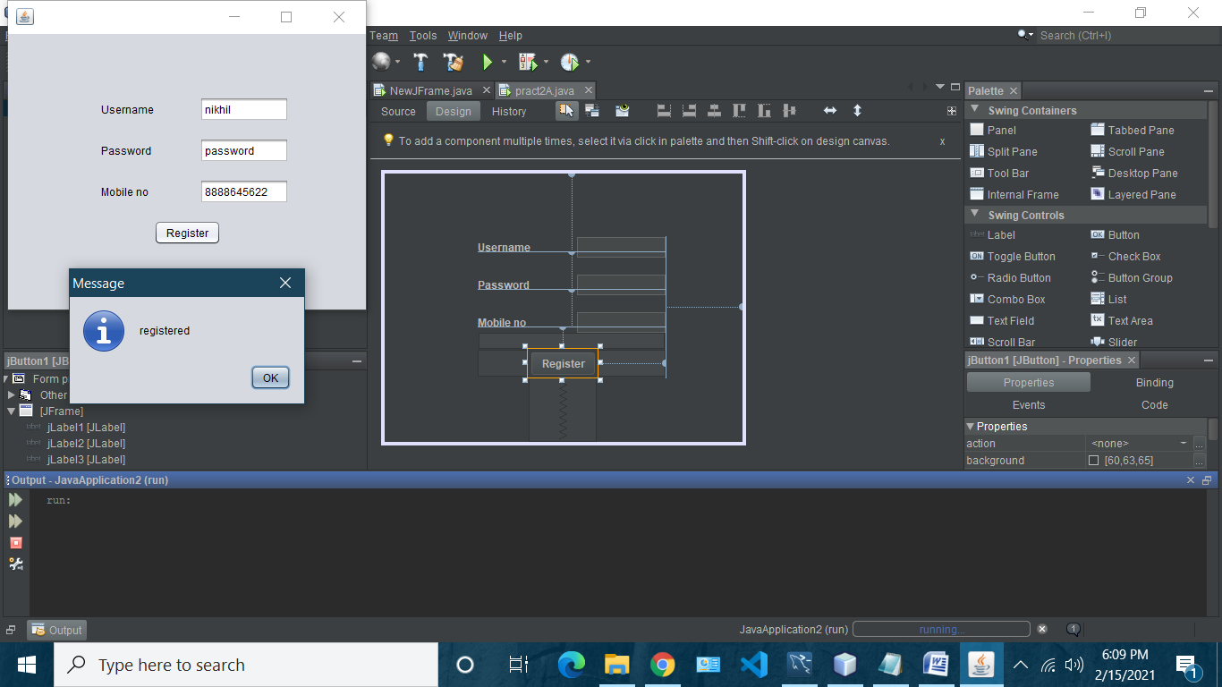

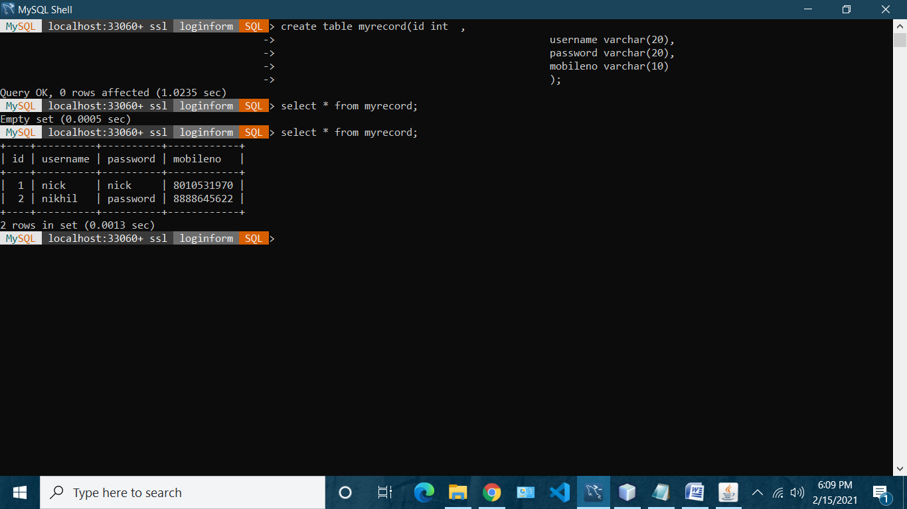

**Practical 3b: login**

import java.sql.Connection;

import java.sql.DriverManager;

import java.sql.ResultSet;

import java.sql.SQLException;

import java.sql.Statement;

import java.util.logging.Level;

import java.util.logging.Logger;

import javax.swing.JOptionPane;

/*

* To change this license header, choose License Headers in Project Properties.

* To change this template file, choose Tools | Templates

* and open the template in the editor.

*/

/**

*

* @author bot

*/

public class NewJFrame extends javax.swing.JFrame {

/**

* Creates new form NewJFrame

*/

public NewJFrame() {

initComponents();

}

/**

* This method is called from within the constructor to initialize the form.

* WARNING: Do NOT modify this code. The content of this method is always

* regenerated by the Form Editor.

*/

@SuppressWarnings("unchecked")

// <editor-fold defaultstate="collapsed" desc="Generated Code">

private void initComponents() {

jTextField1 = new javax.swing.JTextField();

jLabel1 = new javax.swing.JLabel();

jLabel2 = new javax.swing.JLabel();

jButton1 = new javax.swing.JButton();

jPasswordField1 = new javax.swing.JPasswordField();

setDefaultCloseOperation(javax.swing.WindowConstants.EXIT_ON_CLOSE);

jLabel1.setText("Username");

jLabel2.setText("Password");

jButton1.setText("submit");

jButton1.addActionListener(new java.awt.event.ActionListener() {

public void actionPerformed(java.awt.event.ActionEvent evt) {

jButton1ActionPerformed(evt);

}

});

jPasswordField1.setText("jPasswordField1");

javax.swing.GroupLayout layout = new javax.swing.GroupLayout(getContentPane());

getContentPane().setLayout(layout);

layout.setHorizontalGroup(

layout.createParallelGroup(javax.swing.GroupLayout.Alignment.LEADING)

.addGroup(layout.createSequentialGroup()

.addGroup(layout.createParallelGroup(javax.swing.GroupLayout.Alignment.LEADING)

.addGroup(layout.createSequentialGroup()

.addGap(96, 96, 96)

.addGroup(layout.createParallelGroup(javax.swing.GroupLayout.Alignment.LEADING)

.addComponent(jLabel1)

.addComponent(jLabel2))

.addGap(41, 41, 41)

.addGroup(layout.createParallelGroup(javax.swing.GroupLayout.Alignment.LEADING, false)

.addComponent(jTextField1, javax.swing.GroupLayout.DEFAULT_SIZE, 74, Short.MAX_VALUE)

.addComponent(jPasswordField1, javax.swing.GroupLayout.PREFERRED_SIZE, 1, Short.MAX_VALUE)))

.addGroup(layout.createSequentialGroup()

.addGap(149, 149, 149)

.addComponent(jButton1)))

.addContainerGap(73, Short.MAX_VALUE))

);

layout.setVerticalGroup(

layout.createParallelGroup(javax.swing.GroupLayout.Alignment.LEADING)

.addGroup(layout.createSequentialGroup()

.addGap(102, 102, 102)

.addGroup(layout.createParallelGroup(javax.swing.GroupLayout.Alignment.BASELINE)

.addComponent(jTextField1, javax.swing.GroupLayout.PREFERRED_SIZE, javax.swing.GroupLayout.DEFAULT_SIZE, javax.swing.GroupLayout.PREFERRED_SIZE)

.addComponent(jLabel1))

.addGap(18, 18, 18)

.addGroup(layout.createParallelGroup(javax.swing.GroupLayout.Alignment.BASELINE)

.addComponent(jLabel2)

.addComponent(jPasswordField1, javax.swing.GroupLayout.PREFERRED_SIZE, javax.swing.GroupLayout.DEFAULT_SIZE, javax.swing.GroupLayout.PREFERRED_SIZE))

.addGap(18, 18, 18)

.addComponent(jButton1)

.addContainerGap(101, Short.MAX_VALUE))

);

pack();

}// </editor-fold>

private void jButton1ActionPerformed(java.awt.event.ActionEvent evt) {

// TODO add your handling code here:

String uname=jTextField1.getText();

String pass;

pass = String.valueOf(jPasswordField1.getPassword());

//JOptionPane.showMessageDialog(this, pass);

try {

Connection con =DriverManager.getConnection("jdbc:mysql://localhost:3306/loginform?autoReconnect=true&useSSL=false","root","root");

Statement stmt=con.createStatement();

String sql="select * from myrecord where username='"+uname+"' and password='"+pass+"';";

//JOptionPane.showMessageDialog(this, sql);

ResultSet r=stmt.executeQuery(sql);

if(r.next())

{JOptionPane.showMessageDialog(this, "sucess");}

else

{{JOptionPane.showMessageDialog(this, "unsucess");}}

} catch (SQLException ex) {

Logger.getLogger(NewJFrame.class.getName()).log(Level.SEVERE, null, ex);

}

}

/**

* @param args the command line arguments

*/

public static void main(String args[]) {

/* Set the Nimbus look and feel */

//<editor-fold defaultstate="collapsed" desc=" Look and feel setting code (optional) ">

/* If Nimbus (introduced in Java SE 6) is not available, stay with the default look and feel.

* For details see http://download.oracle.com/javase/tutorial/uiswing/lookandfeel/plaf.html

*/

try {

for (javax.swing.UIManager.LookAndFeelInfo info : javax.swing.UIManager.getInstalledLookAndFeels()) {

if ("Nimbus".equals(info.getName())) {

javax.swing.UIManager.setLookAndFeel(info.getClassName());

break;

}

}

} catch (ClassNotFoundException ex) {

java.util.logging.Logger.getLogger(NewJFrame.class.getName()).log(java.util.logging.Level.SEVERE, null, ex);

} catch (InstantiationException ex) {

java.util.logging.Logger.getLogger(NewJFrame.class.getName()).log(java.util.logging.Level.SEVERE, null, ex);

} catch (IllegalAccessException ex) {

java.util.logging.Logger.getLogger(NewJFrame.class.getName()).log(java.util.logging.Level.SEVERE, null, ex);

} catch (javax.swing.UnsupportedLookAndFeelException ex) {

java.util.logging.Logger.getLogger(NewJFrame.class.getName()).log(java.util.logging.Level.SEVERE, null, ex);

}

//</editor-fold>

/* Create and display the form */

java.awt.EventQueue.invokeLater(new Runnable() {

public void run() {

new NewJFrame().setVisible(true);

}

});

}

// Variables declaration - do not modify

private javax.swing.JButton jButton1;

private javax.swing.JLabel jLabel1;

private javax.swing.JLabel jLabel2;

private javax.swing.JPasswordField jPasswordField1;

private javax.swing.JTextField jTextField1;

// End of variables declaration

}

Output:

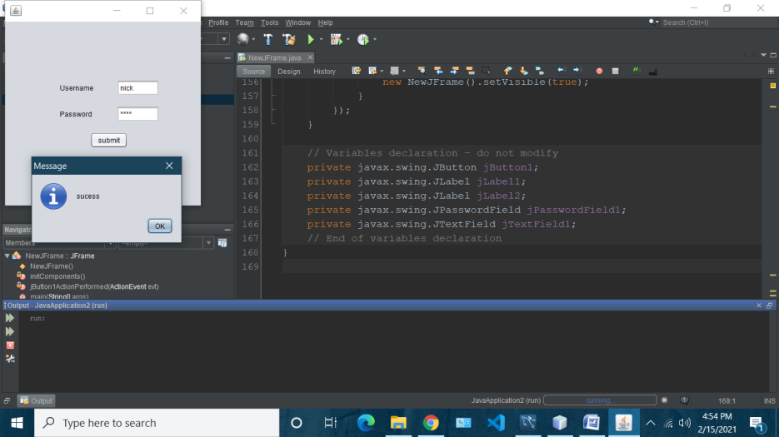

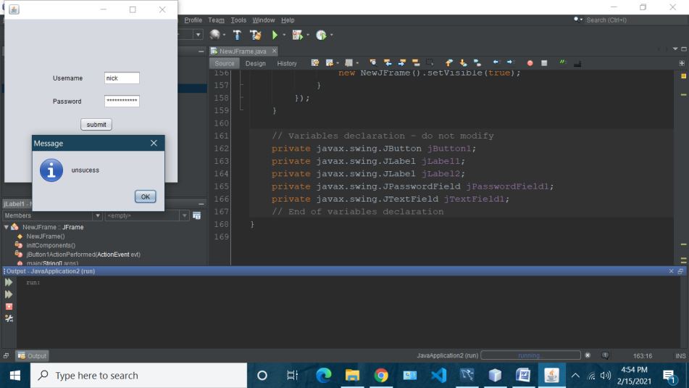

**Practical 3C: Change Password**

import java.sql.Connection;

import java.sql.DriverManager;

import java.sql.ResultSet;

import java.sql.SQLException;

import java.sql.Statement;

import java.util.logging.Level;

import java.util.logging.Logger;

import javax.swing.JOptionPane;

/*

* To change this license header, choose License Headers in Project Properties.

* To change this template file, choose Tools | Templates

* and open the template in the editor.

*/

/**

*

* @author bot

*/

public class chgpass extends javax.swing.JFrame {

/**

* Creates new form chgpass

*/

public chgpass() {

initComponents();

}

/**

* This method is called from within the constructor to initialize the form.

* WARNING: Do NOT modify this code. The content of this method is always

* regenerated by the Form Editor.

*/

@SuppressWarnings("unchecked")

// <editor-fold defaultstate="collapsed" desc="Generated Code">

private void initComponents() {

jLabel1 = new javax.swing.JLabel();

jLabel2 = new javax.swing.JLabel();

jLabel3 = new javax.swing.JLabel();

jLabel4 = new javax.swing.JLabel();

jTextField1 = new javax.swing.JTextField();

jTextField3 = new javax.swing.JTextField();

jButton1 = new javax.swing.JButton();

jPasswordField1 = new javax.swing.JPasswordField();

jPasswordField2 = new javax.swing.JPasswordField();

setDefaultCloseOperation(javax.swing.WindowConstants.EXIT_ON_CLOSE);

jLabel1.setText("Usernme");

jLabel2.setText("Old Password");

jLabel3.setText("Mobile no");

jLabel4.setText("New Password");

jTextField1.addActionListener(new java.awt.event.ActionListener() {

public void actionPerformed(java.awt.event.ActionEvent evt) {

jTextField1ActionPerformed(evt);

}

});

jButton1.setText("Update Password");

jButton1.addActionListener(new java.awt.event.ActionListener() {

public void actionPerformed(java.awt.event.ActionEvent evt) {

jButton1ActionPerformed(evt);

}

});

jPasswordField1.setText("jPasswordField1");

jPasswordField2.setText("jPasswordField2");

javax.swing.GroupLayout layout = new javax.swing.GroupLayout(getContentPane());

getContentPane().setLayout(layout);

layout.setHorizontalGroup(

layout.createParallelGroup(javax.swing.GroupLayout.Alignment.LEADING)

.addGroup(layout.createSequentialGroup()

.addGroup(layout.createParallelGroup(javax.swing.GroupLayout.Alignment.LEADING)

.addGroup(layout.createSequentialGroup()

.addGap(71, 71, 71)

.addGroup(layout.createParallelGroup(javax.swing.GroupLayout.Alignment.TRAILING)

.addComponent(jLabel4)

.addComponent(jLabel3)

.addComponent(jLabel2)

.addComponent(jLabel1))

.addGap(64, 64, 64)

.addGroup(layout.createParallelGroup(javax.swing.GroupLayout.Alignment.LEADING, false)

.addComponent(jTextField1)

.addComponent(jTextField3)

.addComponent(jPasswordField1, javax.swing.GroupLayout.PREFERRED_SIZE, javax.swing.GroupLayout.DEFAULT_SIZE, javax.swing.GroupLayout.PREFERRED_SIZE)

.addComponent(jPasswordField2, javax.swing.GroupLayout.PREFERRED_SIZE, javax.swing.GroupLayout.DEFAULT_SIZE, javax.swing.GroupLayout.PREFERRED_SIZE)))

.addGroup(layout.createSequentialGroup()

.addGap(134, 134, 134)

.addComponent(jButton1)))

.addContainerGap(60, Short.MAX_VALUE))

);

layout.setVerticalGroup(

layout.createParallelGroup(javax.swing.GroupLayout.Alignment.LEADING)

.addGroup(layout.createSequentialGroup()

.addGap(69, 69, 69)

.addGroup(layout.createParallelGroup(javax.swing.GroupLayout.Alignment.BASELINE)

.addComponent(jTextField1, javax.swing.GroupLayout.PREFERRED_SIZE, javax.swing.GroupLayout.DEFAULT_SIZE, javax.swing.GroupLayout.PREFERRED_SIZE)

.addComponent(jLabel1))

.addGap(29, 29, 29)

.addGroup(layout.createParallelGroup(javax.swing.GroupLayout.Alignment.BASELINE)

.addComponent(jLabel2)

.addComponent(jPasswordField1, javax.swing.GroupLayout.PREFERRED_SIZE, javax.swing.GroupLayout.DEFAULT_SIZE, javax.swing.GroupLayout.PREFERRED_SIZE))

.addGap(18, 18, 18)

.addGroup(layout.createParallelGroup(javax.swing.GroupLayout.Alignment.BASELINE)

.addComponent(jTextField3, javax.swing.GroupLayout.PREFERRED_SIZE, javax.swing.GroupLayout.DEFAULT_SIZE, javax.swing.GroupLayout.PREFERRED_SIZE)

.addComponent(jLabel3))

.addGap(18, 18, 18)

.addGroup(layout.createParallelGroup(javax.swing.GroupLayout.Alignment.LEADING)

.addComponent(jLabel4)

.addComponent(jPasswordField2, javax.swing.GroupLayout.PREFERRED_SIZE, javax.swing.GroupLayout.DEFAULT_SIZE, javax.swing.GroupLayout.PREFERRED_SIZE))

.addGap(18, 18, 18)

.addComponent(jButton1)

.addContainerGap(24, Short.MAX_VALUE))

);

pack();

}// </editor-fold>

private void jTextField1ActionPerformed(java.awt.event.ActionEvent evt) {

// TODO add your handling code here:

}

private void jButton1ActionPerformed(java.awt.event.ActionEvent evt) {

// TODO add your handling code here:

try {

String uname= jTextField1.getText();

String pass= String.valueOf(jPasswordField1.getPassword());

String mobileno= jTextField3.getText();

String newpass= String.valueOf(jPasswordField2.getPassword());

Connection conn=DriverManager.getConnection("jdbc:mysql://localhost:3306/loginform?autoReconnect=true&useSSL=false", "root", "root");

Statement stmt =conn.createStatement();

String sql= "select id from myrecord where username='"+ uname

+ "' and password ='"+pass+"' and mobileno='"+mobileno+"';";

ResultSet result=stmt.executeQuery(sql);

if(result.next()){

sql="update myrecord set password='"+newpass+"' where id='"+result.getInt(1)+"';";

stmt.executeUpdate(sql);

JOptionPane.showMessageDialog(this,"your password has been updated");

}

else{

JOptionPane.showMessageDialog(this,"your credentials do not match");

}

} catch (SQLException ex) {

Logger.getLogger(pract2A.class.getName()).log(Level.SEVERE, null, ex);

}

}

/**

* @param args the command line arguments

*/

public static void main(String args[]) {

/* Set the Nimbus look and feel */

//<editor-fold defaultstate="collapsed" desc=" Look and feel setting code (optional) ">

/* If Nimbus (introduced in Java SE 6) is not available, stay with the default look and feel.

* For details see http://download.oracle.com/javase/tutorial/uiswing/lookandfeel/plaf.html

*/

try {

for (javax.swing.UIManager.LookAndFeelInfo info : javax.swing.UIManager.getInstalledLookAndFeels()) {

if ("Nimbus".equals(info.getName())) {

javax.swing.UIManager.setLookAndFeel(info.getClassName());

break;

}

}

} catch (ClassNotFoundException ex) {

java.util.logging.Logger.getLogger(chgpass.class.getName()).log(java.util.logging.Level.SEVERE, null, ex);

} catch (InstantiationException ex) {

java.util.logging.Logger.getLogger(chgpass.class.getName()).log(java.util.logging.Level.SEVERE, null, ex);

} catch (IllegalAccessException ex) {

java.util.logging.Logger.getLogger(chgpass.class.getName()).log(java.util.logging.Level.SEVERE, null, ex);

} catch (javax.swing.UnsupportedLookAndFeelException ex) {

java.util.logging.Logger.getLogger(chgpass.class.getName()).log(java.util.logging.Level.SEVERE, null, ex);

}

//</editor-fold>

/* Create and display the form */

java.awt.EventQueue.invokeLater(new Runnable() {

public void run() {

new chgpass().setVisible(true);

}

});

}

// Variables declaration - do not modify

private javax.swing.JButton jButton1;

private javax.swing.JLabel jLabel1;

private javax.swing.JLabel jLabel2;

private javax.swing.JLabel jLabel3;

private javax.swing.JLabel jLabel4;

private javax.swing.JPasswordField jPasswordField1;

private javax.swing.JPasswordField jPasswordField2;

private javax.swing.JTextField jTextField1;

private javax.swing.JTextField jTextField3;

// End of variables declaration

}

**Output:**

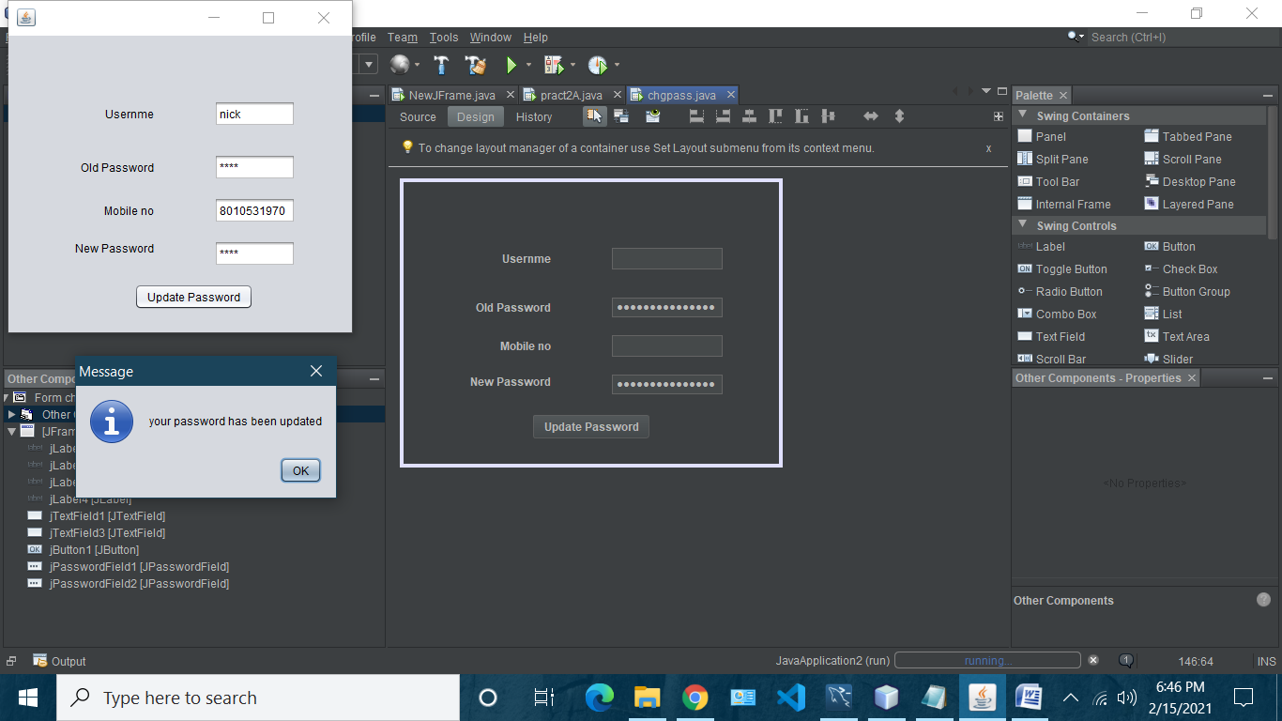

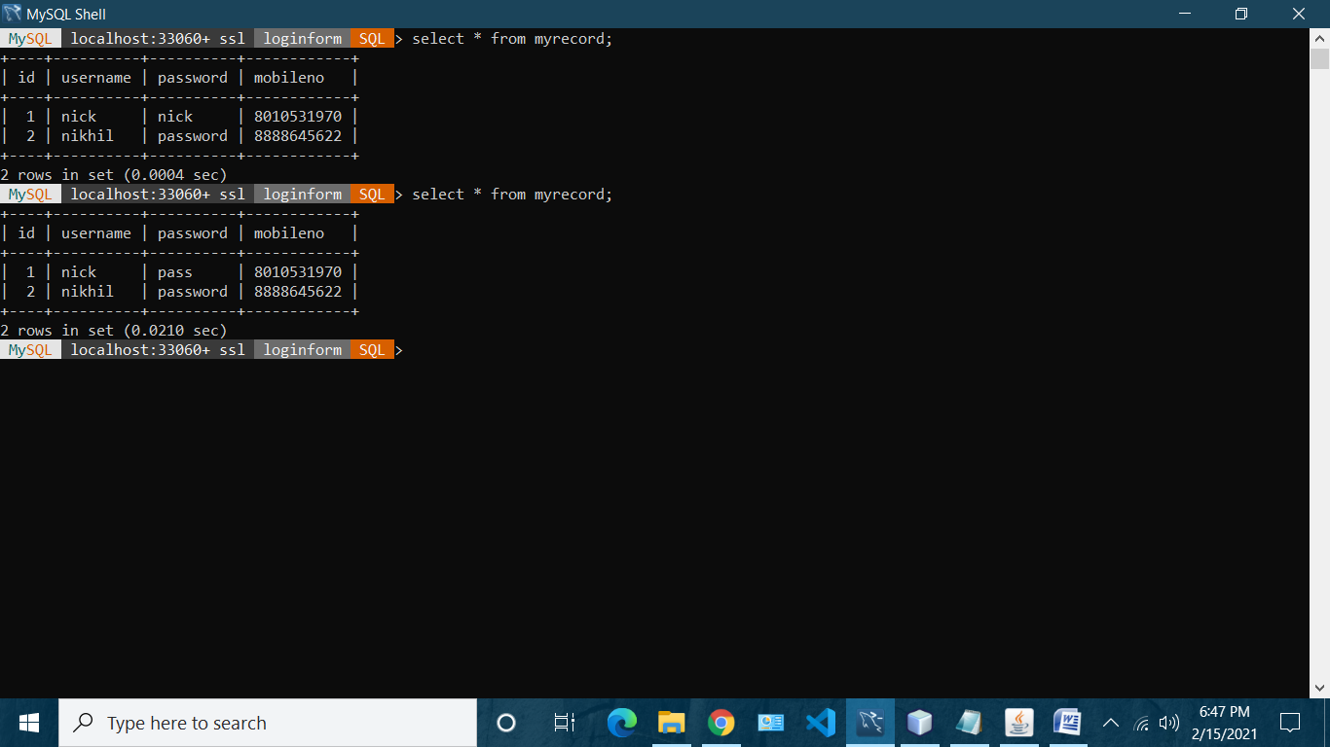

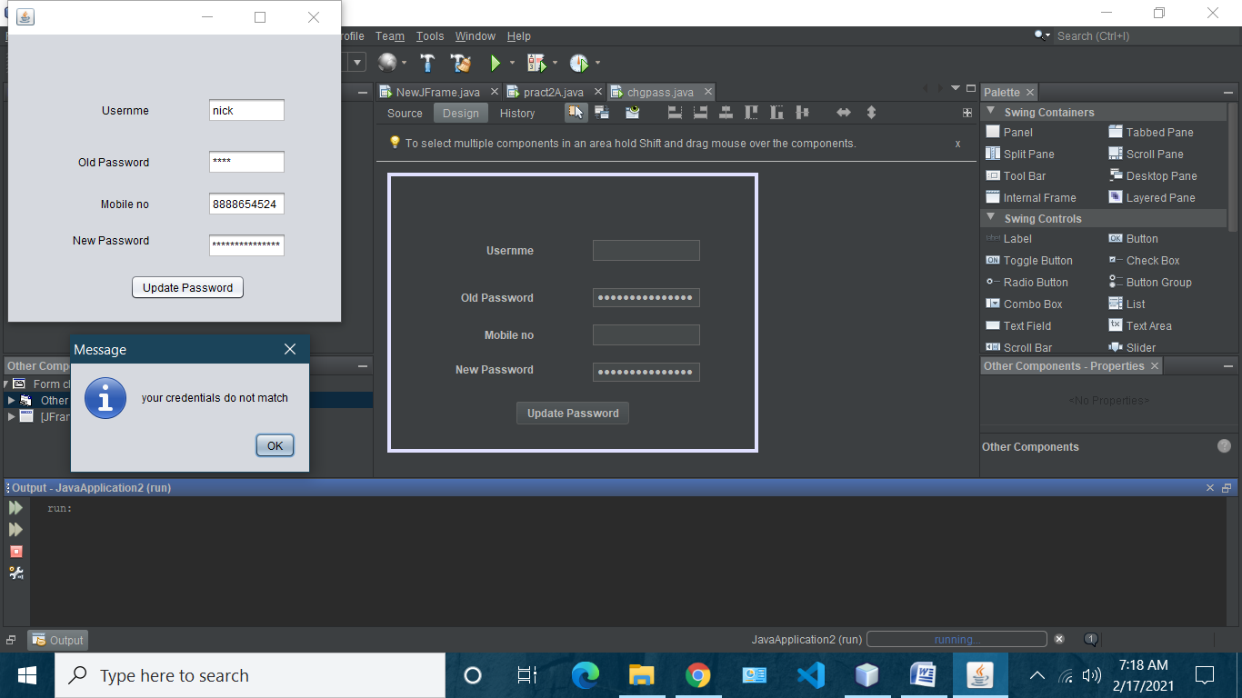

**Practical 3D: Delete Account**

import java.sql.Connection;

import java.sql.DriverManager;

import java.sql.ResultSet;

import java.sql.SQLException;

import java.sql.Statement;

import java.util.logging.Level;

import java.util.logging.Logger;

import javax.swing.JOptionPane;

/*

* To change this license header, choose License Headers in Project Properties.

* To change this template file, choose Tools | Templates

* and open the template in the editor.

*/

/**

*

* @author bot

*/

public class Pract2D extends javax.swing.JFrame {

/**

* Creates new form Pract2D

*/

public Pract2D() {

initComponents();

}

/**

* This method is called from within the constructor to initialize the form.

* WARNING: Do NOT modify this code. The content of this method is always

* regenerated by the Form Editor.

*/

@SuppressWarnings("unchecked")

// <editor-fold defaultstate="collapsed" desc="Generated Code">

private void initComponents() {

jLabel1 = new javax.swing.JLabel();

jLabel2 = new javax.swing.JLabel();

jLabel3 = new javax.swing.JLabel();

jTextField1 = new javax.swing.JTextField();

jTextField3 = new javax.swing.JTextField();

jButton1 = new javax.swing.JButton();

jPasswordField1 = new javax.swing.JPasswordField();

setDefaultCloseOperation(javax.swing.WindowConstants.EXIT_ON_CLOSE);

jLabel1.setText("Usernme");

jLabel2.setText("Password");

jLabel3.setText("Mobile no");

jTextField1.addActionListener(new java.awt.event.ActionListener() {

public void actionPerformed(java.awt.event.ActionEvent evt) {

jTextField1ActionPerformed(evt);

}

});

jButton1.setText("Delete record");

jButton1.addActionListener(new java.awt.event.ActionListener() {

public void actionPerformed(java.awt.event.ActionEvent evt) {

jButton1ActionPerformed(evt);

}

});

jPasswordField1.setText("jPasswordField1");

javax.swing.GroupLayout layout = new javax.swing.GroupLayout(getContentPane());

getContentPane().setLayout(layout);

layout.setHorizontalGroup(

layout.createParallelGroup(javax.swing.GroupLayout.Alignment.LEADING)

.addGroup(layout.createSequentialGroup()

.addGroup(layout.createParallelGroup(javax.swing.GroupLayout.Alignment.LEADING)

.addGroup(layout.createSequentialGroup()

.addGap(77, 77, 77)

.addGroup(layout.createParallelGroup(javax.swing.GroupLayout.Alignment.TRAILING)

.addComponent(jLabel3)

.addComponent(jLabel2)

.addComponent(jLabel1))

.addGap(64, 64, 64)

.addGroup(layout.createParallelGroup(javax.swing.GroupLayout.Alignment.LEADING, false)

.addComponent(jTextField1)

.addComponent(jTextField3)

.addComponent(jPasswordField1, javax.swing.GroupLayout.PREFERRED_SIZE, javax.swing.GroupLayout.DEFAULT_SIZE, javax.swing.GroupLayout.PREFERRED_SIZE)))

.addGroup(layout.createSequentialGroup()

.addGap(137, 137, 137)

.addComponent(jButton1)))

.addContainerGap(82, Short.MAX_VALUE))

);

layout.setVerticalGroup(

layout.createParallelGroup(javax.swing.GroupLayout.Alignment.LEADING)

.addGroup(layout.createSequentialGroup()

.addGap(69, 69, 69)

.addGroup(layout.createParallelGroup(javax.swing.GroupLayout.Alignment.BASELINE)

.addComponent(jTextField1, javax.swing.GroupLayout.PREFERRED_SIZE, javax.swing.GroupLayout.DEFAULT_SIZE, javax.swing.GroupLayout.PREFERRED_SIZE)

.addComponent(jLabel1))

.addGap(29, 29, 29)

.addGroup(layout.createParallelGroup(javax.swing.GroupLayout.Alignment.LEADING)

.addComponent(jPasswordField1, javax.swing.GroupLayout.PREFERRED_SIZE, javax.swing.GroupLayout.DEFAULT_SIZE, javax.swing.GroupLayout.PREFERRED_SIZE)

.addComponent(jLabel2))

.addGap(18, 18, 18)

.addGroup(layout.createParallelGroup(javax.swing.GroupLayout.Alignment.BASELINE)

.addComponent(jTextField3, javax.swing.GroupLayout.PREFERRED_SIZE, javax.swing.GroupLayout.DEFAULT_SIZE, javax.swing.GroupLayout.PREFERRED_SIZE)

.addComponent(jLabel3))

.addGap(36, 36, 36)

.addComponent(jButton1)

.addContainerGap(46, Short.MAX_VALUE))

);

pack();

}// </editor-fold>

private void jTextField1ActionPerformed(java.awt.event.ActionEvent evt) {

// TODO add your handling code here:

}

private void jButton1ActionPerformed(java.awt.event.ActionEvent evt) {

// TODO add your handling code here:

try {

String uname= jTextField1.getText();

String pass= String.valueOf(jPasswordField1.getPassword());

String mobileno= jTextField3.getText();

Connection conn=DriverManager.getConnection("jdbc:mysql://localhost:3306/loginform?autoReconnect=true&useSSL=false", "root", "root");

Statement stmt =conn.createStatement();

String sql= "select id from myrecord where username='"+ uname

+ "' and password ='"+pass+"' and mobileno='"+mobileno+"';";

ResultSet result=stmt.executeQuery(sql);

if(result.next()){

sql="Delete from myrecord where id='"+result.getInt(1)+"';";

stmt.executeUpdate(sql);

JOptionPane.showMessageDialog(this,"your Account has been Deleted");

}

else{

JOptionPane.showMessageDialog(this,"Record does not exist");

}

} catch (SQLException ex) {

Logger.getLogger(pract2A.class.getName()).log(Level.SEVERE, null, ex);

}

}

/**

* @param args the command line arguments

*/

public static void main(String args[]) {

/* Set the Nimbus look and feel */

//<editor-fold defaultstate="collapsed" desc=" Look and feel setting code (optional) ">

/* If Nimbus (introduced in Java SE 6) is not available, stay with the default look and feel.

* For details see http://download.oracle.com/javase/tutorial/uiswing/lookandfeel/plaf.html

*/

try {

for (javax.swing.UIManager.LookAndFeelInfo info : javax.swing.UIManager.getInstalledLookAndFeels()) {

if ("Nimbus".equals(info.getName())) {

javax.swing.UIManager.setLookAndFeel(info.getClassName());

break;

}

}

} catch (ClassNotFoundException ex) {

java.util.logging.Logger.getLogger(Pract2D.class.getName()).log(java.util.logging.Level.SEVERE, null, ex);

} catch (InstantiationException ex) {

java.util.logging.Logger.getLogger(Pract2D.class.getName()).log(java.util.logging.Level.SEVERE, null, ex);

} catch (IllegalAccessException ex) {

java.util.logging.Logger.getLogger(Pract2D.class.getName()).log(java.util.logging.Level.SEVERE, null, ex);

} catch (javax.swing.UnsupportedLookAndFeelException ex) {

java.util.logging.Logger.getLogger(Pract2D.class.getName()).log(java.util.logging.Level.SEVERE, null, ex);

}

//</editor-fold>

/* Create and display the form */

java.awt.EventQueue.invokeLater(new Runnable() {

public void run() {

new Pract2D().setVisible(true);

}

});

}

// Variables declaration - do not modify

private javax.swing.JButton jButton1;

private javax.swing.JLabel jLabel1;

private javax.swing.JLabel jLabel2;

private javax.swing.JLabel jLabel3;

private javax.swing.JPasswordField jPasswordField1;

private javax.swing.JTextField jTextField1;

private javax.swing.JTextField jTextField3;

// End of variables declaration

}

**Output:**

